DBMS ASSIGNMENT
- Creation of Database.

Create table Student(
SNo number(4) not null unique,
AppRegNo Varchar2(9) not null unique,
RollNo number(11) primary key,
Sname varchar2(50),
Gender varchar2(7),
Catergory varchar(4),
Pwd varchar2(3),
DOB date,
Prog_Name varchar2(3) DEFAULT 'MCA',
Prg_Code number(3) DEFAULT 105,
Marks_Obtained number(3) check (Marks_Obtained >= 0 and Marks_Obtained <=400),
Merit_Order number(3) not null unique,
PassingState varchar2(20));

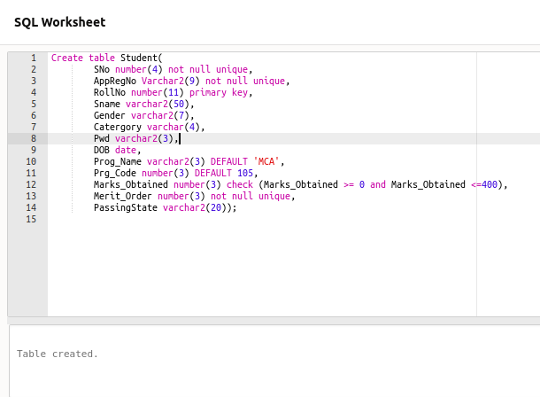

2. Insert values in the Database.
insert into Student(SNo,AppRegNo,RollNo,Sname,Gender,Catergory,Pwd,DOB,Marks_Obtained,Merit_Order,PassingState)
values(1,'IPU209747',11105120198,'PARAG DUDEJA','Male','UR','No',TO_DATE('19/7/1999', 'DD/MM/YYYY'),330,1,'Delhi');
insert into Student(SNo,AppRegNo,RollNo,Sname,Gender,Catergory,Pwd,DOB,Marks_Obtained,Merit_Order,PassingState)
values(2,'IPU087941',11105180092,'VIPIN KUMAR MALIK','Male','UR','No',TO_DATE('22/1/1999', 'DD/MM/YYYY'),302,2,'Delhi');
insert into Student(SNo,AppRegNo,RollNo,Sname,Gender,Catergory,Pwd,DOB,Marks_Obtained,Merit_Order,PassingState)
values(3,'IPU144573',11105130138,'RAMAN MITTAL','Male','UR','No',TO_DATE('21/6/1999', 'DD/MM/YYYY'),302,3,'Delhi');
insert into Student(SNo,AppRegNo,RollNo,Sname,Gender,Catergory,Pwd,DOB,Marks_Obtained,Merit_Order,PassingState)
values(4,'IPU142819',11105150119,'ARMAAN SAINI','Male','UR','No',TO_DATE('19/7/1998', 'DD/MM/YYYY'),301,4,'Delhi');
insert into Student(SNo,AppRegNo,RollNo,Sname,Gender,Catergory,Pwd,DOB,Marks_Obtained,Merit_Order,PassingState)
values(5,'IPU066878',11105160123,'MANISH BISHT','Male','UR','No',TO_DATE('28/12/1999', 'DD/MM/YYYY'),301,5,'Delhi');
insert into Student(SNo,AppRegNo,RollNo,Sname,Gender,Catergory,Pwd,DOB,Marks_Obtained,Merit_Order,PassingState)
values(6,'IPU080102',11105130084,'SHIVANG TRIPATHI','Male','UR','No',TO_DATE('19/8/1999', 'DD/MM/YYYY'),298,6,'Delhi');
insert into Student(SNo,AppRegNo,RollNo,Sname,Gender,Catergory,Pwd,DOB,Marks_Obtained,Merit_Order,PassingState)
values(7,'IPU121195',11105160255,'MAYANK DUA','Male','UR','No',TO_DATE('2/2/1999', 'DD/MM/YYYY'),297,7,'Delhi');
insert into Student(SNo,AppRegNo,RollNo,Sname,Gender,Catergory,Pwd,DOB,Marks_Obtained,Merit_Order,PassingState)
values(8,'IPU245999',11105180229,'MANAN AGGARWAL','Male','UR','No',TO_DATE('29/9/1998', 'DD/MM/YYYY'),296,8,'Delhi');
insert into Student(SNo,AppRegNo,RollNo,Sname,Gender,Catergory,Pwd,DOB,Marks_Obtained,Merit_Order,PassingState)
values(9,'IPU092385',11105170105,'ROOHI SHARMA','Female','UR','No',TO_DATE('25/12/1998', 'DD/MM/YYYY'),295,9,'Delhi');
insert into Student(SNo,AppRegNo,RollNo,Sname,Gender,Catergory,Pwd,DOB,Marks_Obtained,Merit_Order,PassingState)
values(10,'IPU252029',11105160451,'NEHA JAIN','Female','UR','No',TO_DATE('20/9/1999', 'DD/MM/YYYY'),294,10,'Delhi');
insert into Student(SNo,AppRegNo,RollNo,Sname,Gender,Catergory,Pwd,DOB,Marks_Obtained,Merit_Order,PassingState)
values(11,'IPU081041',11105180081,'NEHA THAKRAN','Female','UR','No',TO_DATE('9/6/1998', 'DD/MM/YYYY'),290,11,'Delhi');
insert into Student(SNo,AppRegNo,RollNo,Sname,Gender,Catergory,Pwd,DOB,Marks_Obtained,Merit_Order,PassingState)
values(12,'IPU029998',11105150019,'AASTHA GUPTA','Female','UR','No',TO_DATE('2/2/2000', 'DD/MM/YYYY'),278,12,'Delhi');
insert into Student(SNo,AppRegNo,RollNo,Sname,Gender,Catergory,Pwd,DOB,Marks_Obtained,Merit_Order,PassingState)
values(13,'IPU001192',11105180001,'KRITI KAPOOR','Female','UR','No',TO_DATE('04/9/1999', 'DD/MM/YYYY'),277,13,'Delhi');
insert into Student(SNo,AppRegNo,RollNo,Sname,Gender,Catergory,Pwd,DOB,Marks_Obtained,Merit_Order,PassingState)
values(14,'IPU078054',11105110009,'UMESH SONI','Male','OBC','No',TO_DATE('16/7/2000', 'DD/MM/YYYY'),277,14,'Delhi');
insert into Student(SNo,AppRegNo,RollNo,Sname,Gender,Catergory,Pwd,DOB,Marks_Obtained,Merit_Order,PassingState)
values(15,'IPU168089',11105160331,'AMAN RAJ','Male','UR','No',TO_DATE('30/9/1998', 'DD/MM/YYYY'),276,15,'Delhi');

